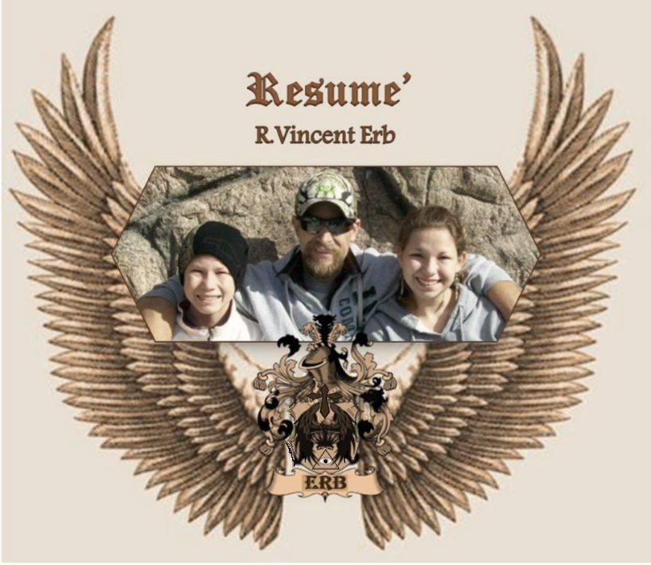

R.Vincent Erb
3823 Leesburg Rd. Fort Wayne, IN 46808
(260) 466-7739
vinnivanhood@badassdistribution.com

____________________________________________________________

As a current student at Ivy Tech I study computer aided design. I also offer automotive brake replacement services thru my own small business. With my uniquely diverse experience and training coupled with my reliability and diligence I offer a valuable collection of qualities to any employer. I also have computer skills which include proficiency with Word, Power Point, and Solidworks 3D design software.
____________________________________________________________
Education:
IVY TECH Community College: Sophomore in Design Program with mechanical concentration
I maintain a perfect 4.0 GPA, have just three remaining classes, and will graduate in 2013
Supervisor Training
Hazardous Waste Management Training
Basic First Aid Training
Southwood Jr./Sr. High School: Graduated Class of `87

Driver/Operator License:
Indiana Chauffeurs License with motorcycle endorsement
Experienced with straight truck, fork truck, electric mold cart, and skid steer
HAM radio license KC9MRB

Other:
My business’s assets include two registered Indiana Trademarks, several copyrighted documents
and designs, and numerous webpages that I oversee. Aside from brake and road services I also
offer a resume’ creation service.

I own a group that I formed in Oct. 2012 called Fort Wayne Design Students and Enthusiasts.
The group’s assets include a LinkedIn group, Facebook page, and its primary website all of
which I am also the administrator of.

Links to all of my webpages and more can be found at: http://rvincenterb.weebly.com

R.Vincent Erb
3823 Leesburg Rd. Fort Wayne, IN 46808
(260) 466-7739
vinnivanhood@badassdistribution.com

_____________________________________________________________________

Work Experience:
10/`11-Present B.A.D.™ LLC (260)466-7739
Give Me A Brake!™ disk brake replacement service
President: Own & Operate
10/`06-10/`11 AGING AND IN-HOME SERVICES (260)745-1200
2927 Lake Ave. Fort Wayne, IN 46805
Motor Route Carrier: Delivered hot meals to the home-bound
11/`04-07/`05 TRANSWHEEL/TRANSMETCO (Staffmark) 1-800-943-3577
4000 Yeoman Way Huntington, IN 46750
Wheel Sorter: Unloaded semi-trailers with skid steer and fork trucks, sorted &
ID’d wheels, loaded furnace, and drove straight truck

04/`02-12/`05 MOTOR ROUTE CARRIER: for several newspapers
& Delivered, billing and collection
02/`07-09/`07 FORT WAYNE NEWSPAPERS (260)461-8444
PERU TRIBUNE (765)473-6641
WABASH PLAIN DEALER (260)563-2131

07/`94-04/`03 WABASH MAGNETICS CONTROL PRODUCTS GROUP closed
1450 First St. Wabash, IN 46992
Group Leader: Responsible for all 3rd shift operations, supervision, material
handling, maintenance (injection molding), quality assurance(digital calipers,
charting), training, mold changing-job setup, plant start-up & shutdown, and
building security

06/`85-08/`93 PINE FARM GREENHOUSES INC. closed
2792 S. River Rd. Wabash, IN 46992
General Laborer: Stocking, receiving, lawn care, plant care, delivered, and
operated flat-filler

R.Vincent Erb
3823 Leesburg Rd. Fort Wayne, IN 46808
(260) 466-7739
vinnivanhood@badassdistribution.com

_____________________________________________________________________

References:

Renee’ Baughman
Prior Supervisor Aging & In-Home Services
Known for seven years
1715 Hensch St.
Fort Wayne, IN 46808
(260) 423-9623

Justin Lewis
3D Scanning Technician
Known for 10 years
6730 Lawnwood Dr.
Fort Wayne, IN 46815
(260) 226-2789

Lindsey Swalley
Graphic Design, Ecommerce Design & Development
Known for five years
2510 Sherborne Blvd.
Fort Wayne, IN 46805
(260) 385-5534

Kris Henderson
Manufacturing associate
Known for 30 years
PO Box 162
Huntington, In 46750
(765) 251-0907

